Dear Parents/Carers/Students

Our New App

We are pleased to announce that we have a new App designed to make our communication with you easier, quicker and more efficient.

If you have a smartphone you can download our App from the Apple App Store or Google Play Store (Android) for FREE.

Our App will allow us to keep you updated with News, Information, Events and will have links to all the other websites and Apps we use so that you have one centralised place to access those.

When we update the App with new information or news about us, a message will be automatically sent to your device of this update. You can then view the notification which will then take you directly to our App.

How to get started

Either:

- Using your device (phone or tablet), For Apple go here https://tinyurl.com/y9ad3j7u and Android go here https://tinyurl.com/y7cssjwt then install, click on our school and sign up

- Using your device (iPad, iPhone, tablet or Android phone), visit the relevant store as you would normally (Apple Store or Google Play) and search for “Maged School” you should find an icon when you scroll through that looks like the image below, click on it and install it. Then click on our school and sign up

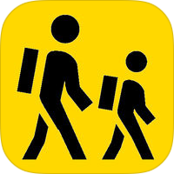

You will then have all our news, information, calendar events, contacts and links to all other websites and Apps at your fingertips.

If you want to find out more about our App provider Maged please go to www.maged.cc

Please help us to save money, the more its downloaded the more we will save in communication costs.

Yours sincerely,

